**Balance Sheet Statement**

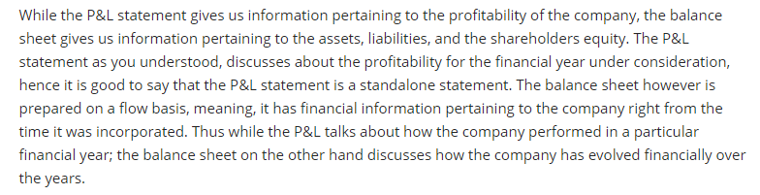

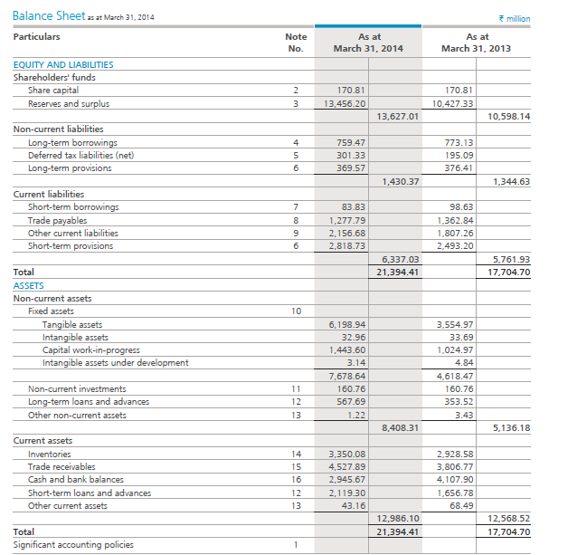

**Assets**, both tangible and intangible are owned by the company. An asset is a resource controlled by the company, and is expected to have an economic value in the future. Typical examples of assets include plants, machinery, cash, brands, patents etc. Assets are of two types, current and non-current

**Liability** on the other hand represents the company’s obligation. The obligation is taken up by the company because the company believes these obligations will provide economic value in the long run. Liability in simple words is the loan that the company has taken and it is therefore obligated to repay back.  Typical examples of obligation include short term borrowing, long term borrowing, payments due etc. Liabilities are of two types namely current and non-current.

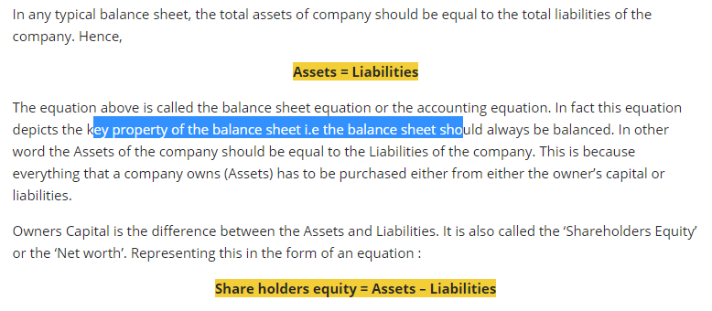

balance sheet has two main sections i.e. the assets and the liabilities.

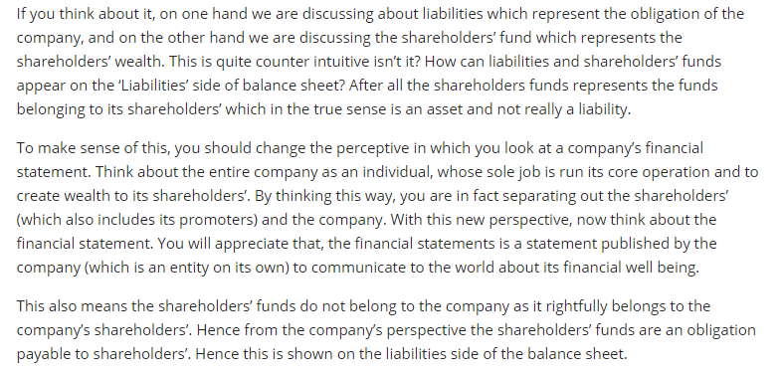

**The liability side of balance sheet**

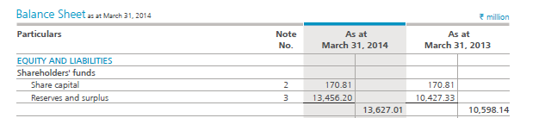

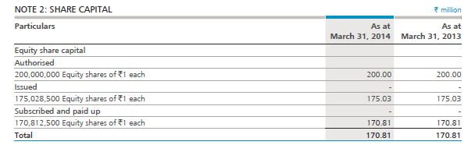

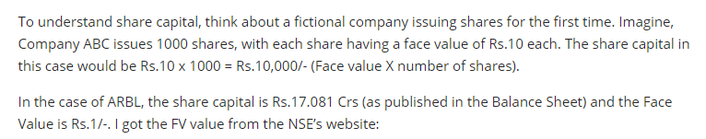

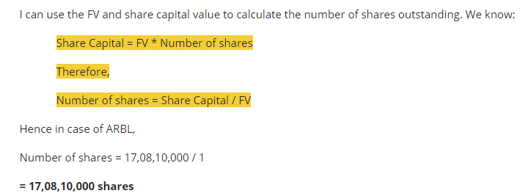

The next line item on the liability side of the Balance Sheet is the ‘**Reserves and Surplus**’. Reserves are usually money earmarked by the company for specific purposes. Surplus is where all the profits of the company reside.

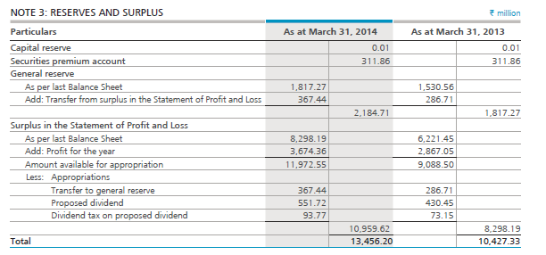

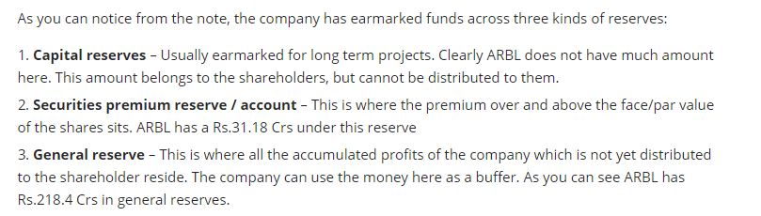

surplus holds the profits made during the year.

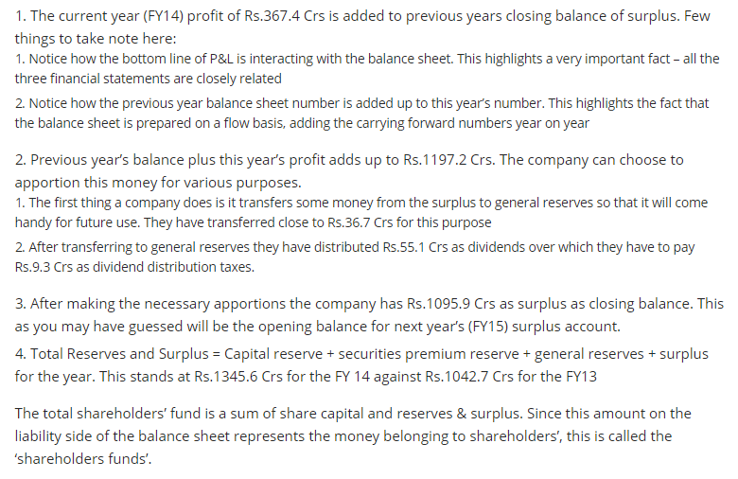

## Non Current Liabilities

## Non-current liabilities represent the long term obligations, which the company intends to settle/ pay off not within 365 days/ 12 months of the balance sheet date. These obligations stay on the books for few years. Non-current liabilities are generally settled after 12 months after the reporting period.

## 

## 

## **The long term borrowing** (associated with note 4) is the first line item within the non-current liabilities. Long term borrowing is one of the most important line item in the entire balance sheet as it represents the amount of money that the company has borrowed through various sources. Long term borrowing is also one of the key inputs while calculating some of the financial ratios.

## 

## we looked at ‘Finance Cost’ as a line item when we looked at the P&L statement. If the debt of the company is high, then the finance cost will also be high.

## 

## Current liabilities

Current liabilities are a company’s obligations which are expected to be settled within 365 days (less than 1 year).

## 

## these are short term obligations of the company usually undertaken by the company to meet day to day cash requirements (also called working capital requirements).

## 

## 

## Usually ‘Other current Liabilities’ are obligations associated with the statutory requirements and obligations that are not directly related to the operations of the company.

## The last line item in current liabilities is the ‘Short term provisions’ which stands at Rs.281.8 Crs. Short term provisions is quite similar to long term provisions, both of which deals with setting aside funds for employee benefits such as gratuity, leave encashment, provident funds etc. Interestingly the note associated with ‘Short term Provisions’ and the ‘Long term provisions’ is the same.

## ****Total Liability = Shareholders’ Funds + Non Current Liabilities + Current Liabilities****

## The Assets side of Balance Sheet

## We will now proceed to understand the 2nd half of the balance sheet i.e the Asset side of the balance sheet. The Asset side shows us all the assets the company owns (in different forms) right from its inception. Assets in simple terms are the resources held by a company, which help in generating the revenues.

## 

## Non-current assets (Fixed Assets)

Fixed assets are assets (both tangible and intangible) that the company owns which cannot be converted to cash easily or which cannot be liquidated easily. Typical examples of fixed assets are land, plant and machinery, vehicles, building etc. Intangible assets are also considered fixed assets because they benefit companies over a long period of time.

Tangible assets consists of assets which has a physical form. In other words these assets can be seen or touched. This usually includes plant and machinery, vehicles, buildings, fixtures etc.

Intangible assets are assets which have an economic value, but do not have a physical nature. This usually includes patents, copyrights, trademarks, designs etc.

Depreciation is a way of spreading the cost of acquiring the asset over its useful life. The value of the assets deplete over time, as the assets lose their productive capacity due to obsolescence and physical wear and tear. This value is called the Depreciation expense, which is shown in the Profit and Loss account and the Balance Sheet.

All the assets should be depreciated over its useful life. Keeping this in perspective, when the company acquires an asset it is called the ‘Gross Block’. Depreciation should be deducted from the Gross block, after which we can arrive at the ‘Net Block’.

**Net Block = Gross Block –Accumulated Depreciation**

the term ‘Accumulated’ is used to indicate all the depreciation value since the incorporation of the company.

When we read tangible assets at Rs.619.8 Crs and Intangible assets at Rs.3.2 Crs, do remember the company is reporting its Net block, which is Net of Accumulated depreciation.

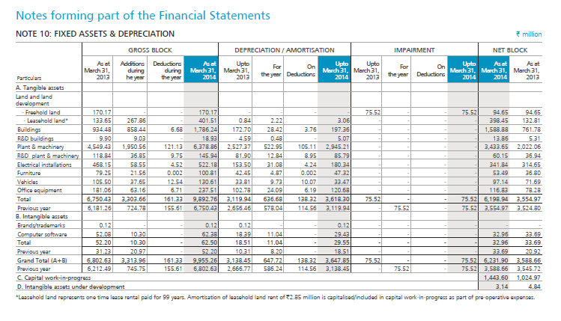

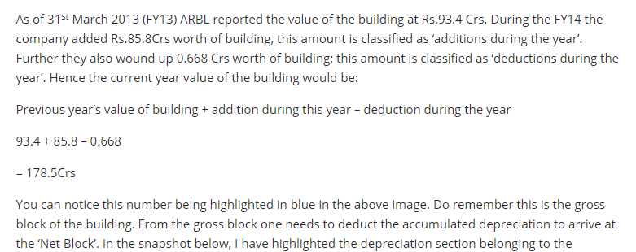

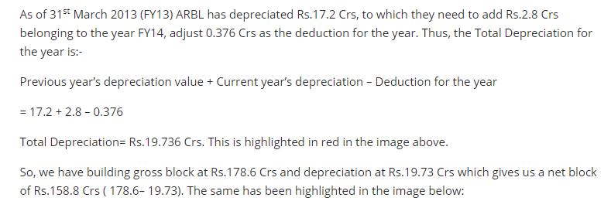

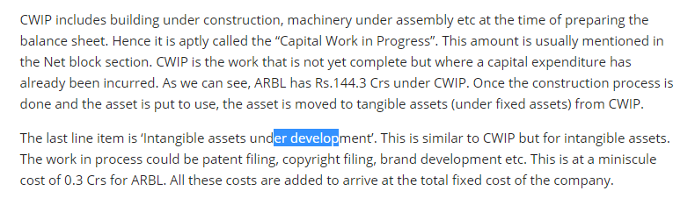

## Current assets

## 

## The next line item is ‘Trade Receivables’ also referred to as ‘Accounts Receivables’. This represents the amount of money that the company is expected to receive from its distributors, customers and other related parties. The trade receivable for ARBL stands at Rs.452.7 Crs.

## 

## 

## Connecting the P&L and Balance Sheet

## 

## 